***Business Analytics, 2e, GE* (Evans)**

**Chapter 7 Statistical Inference**

1) Which of the following propositions describes an existing theory or belief?

A) standard deviation

**B) null hypothesis**

C) proportion

D) alternative hypothesis

Answer: B

Diff: 1

Blooms: Remember

Topic: Hypothesis Testing

LO1: Explain the difference between the null and alternative hypotheses.

LO2: Compare and contrast the major types of hypothesis testing for one-sample tests

2) Which of the following is the initial step in conducting a hypothesis test?

A) collecting data and calculating a test statistic

B) selecting a level of significance

**C) identifying the population parameter of interest**

D) determining a decision rule

Answer: C

Diff: 1

Blooms: Remember

Topic: Hypothesis Testing

LO1: List the steps in the hypothesis-testing procedure.

LO2: Compare and contrast the major types of hypothesis testing for one-sample tests

3) Which of the following is a valid one-sample hypothesis test?

A) *H*0: population parameter ≠ constant vs. *H*1: population parameter = constant

B) *H*0: population parameter > constant vs. *H*1: population parameter ≤ constant

C) *H*0: population parameter < constant vs. *H*1: population parameter ≥ constant

**D) *H*0: population parameter = constant vs. *H*1: population parameter ≠ constant**

Answer: D

Diff: 1

Blooms: Remember

Topic: One-Sample Hypothesis Tests

LO1: State the proper forms of hypotheses for one-sample hypothesis tests.

LO2: Compare and contrast the major types of hypothesis testing for one-sample tests

4) A manufacturer wishes to determine if the average profit from the sale of his product exceeds $6,710. Which of the following is the appropriate hypothesis test?

A) *H*0: population mean profit from sale > $6,710 vs. *H*1: population mean profit from sale ≤ $6,710

**B) *H*0: population mean profit from sale ≤ $6,710 vs. *H*1: population mean profit from sale > $6,710**

C) *H*0: population mean profit from sale < $6,710 vs. *H*1: population mean profit from sale ≥ $6,710

D) *H*0: population mean profit from sale ≥ $6,710 vs. *H*1: population mean profit from sale < $6,710

Answer: B

Diff: 2

Blooms: Apply

Topic: One-Sample Hypothesis Tests

LO1: Correctly formulate hypotheses

LO2: Compare and contrast the major types of hypothesis testing for one-sample tests

5) Which of the following is true about determining the proper form of the hypotheses?

A) *H*0 is statistically proved true while testing

B) failure to reject *H*0 proves *H*1 wrong

**C) *H*0 is always assumed to be true in testing**

D) *H*1 is always assumed to be true in testing

Answer: C

Diff: 2

Blooms: Understand

Topic: One-Sample Hypothesis Tests

LO1: Correctly formulate hypotheses

LO2: Compare and contrast the major types of hypothesis testing for one-sample tests

6) Which of the following is a Type I error?

A) the null hypothesis is actually true, and the hypothesis test correctly fails to reject it

B) the null hypothesis is actually false, but the test incorrectly fails to reject it

C) the null hypothesis is actually false, and the test correctly rejects it

**D) the null hypothesis is actually true, but the hypothesis test incorrectly rejects it**

Answer: D

Diff: 2

Blooms: Remember

Topic: One-Sample Hypothesis Tests

LO1: Explain the difference between Type I and Type II errors.

LO2: Compare and contrast the major types of hypothesis testing for one-sample tests

7) Robin Inc. feared that the average company loss is running beyond $34,000. It initially conducted a hypothesis test on a sample extracted from its database. The hypothesis was formulated as *H*0: average company loss $34,000 vs. *H*1: average company loss > $34,000. The test resulted in favor of Robin Inc.'s loss not exceeding $34,000. Detailed study of company accounts later revealed that the average company loss had run up to $37,896. Which of the following errors were made during the hypothesis test?

A) Type III error

**B) Type II error**

C) Type I error

D) Type IV error

Answer: B

Diff: 1

Blooms: Apply

Topic: One-Sample Hypothesis Tests

LO1: Explain the difference between Type I and Type II errors.

LO2: Compare and contrast the major types of hypothesis testing for one-sample tests

8) Type II error occurs when the test:

A) correctly fails to reject an actually true null hypothesis.

**B) incorrectly fails to reject an actually false null hypothesis.**

C) correctly rejects an actually false null hypothesis.

D) incorrectly rejects an actually true null hypothesis.

Answer: B

Diff: 2

Blooms: Remember

Topic: One-Sample Hypothesis Tests

LO1: Explain the difference between Type I and Type II errors.

LO2: Compare and contrast the major types of hypothesis testing for one-sample tests

9) Level of significance is the probability of:

**A) incorrectly rejecting an actually true null hypothesis.**

B) correctly failing to reject an actually true null hypothesis.

C) incorrectly failing to reject an actually false null hypothesis.

D) correctly rejecting an actually false null hypothesis.

Answer: A

Diff: 1

Blooms: Remember

Topic: One-Sample Hypothesis Tests

LO1: Explain the difference between Type I and Type II errors.

LO2: Compare and contrast the major types of hypothesis testing for one-sample tests

10) The confidence coefficient is denoted by:

A) *α*

B) 1 - *β*

C) *β*

**D) 1 - *α***

Answer: D

Diff: 1

Blooms: Remember

Topic: One-Sample Hypothesis Tests

LO1: Explain the difference between Type I and Type II errors.

LO2: Compare and contrast the major types of hypothesis testing for one-sample tests

11) What is the confidence coefficient when the level of significance is 0.03?

**A) 0.9700**

B) 0.0376

C) 0.7924

D) 0.7776

Answer: A

Diff: 1

Blooms: Apply

Topic: One-Sample Hypothesis Tests

LO1: Explain the difference between Type I and Type II errors.

LO2: Compare and contrast the major types of hypothesis testing for one-sample tests

12) Which of the following denotes the power of the test?

A) *α*

**B) 1 - *β***

C) *β*

D) 1 - *α*

Answer: B

Diff: 1

Blooms: Remember

Topic: One-Sample Hypothesis Tests

LO1: Explain the difference between Type I and Type II errors.

LO2: Compare and contrast the major types of hypothesis testing for one-sample tests

13) Which of the following probabilities gives the confidence coefficient?

A) *P*(rejecting *H*0 | *H*0 is true)

B) *P*(not rejecting *H*0 | *H*0 is false)

C) *P*(rejecting *H*0 | *H*0 is false)

**D) *P*(not rejecting *H*0 | *H*0 is true)**

Answer: D

Diff: 1

Blooms: Remember

Topic: One-Sample Hypothesis Tests

LO1: Explain the difference between Type I and Type II errors.

LO2: Compare and contrast the major types of hypothesis testing for one-sample tests

14) Identify the power of the test from the following probabilities.

A) *P*(rejecting *H*0 | *H*0 is true)

B) *P*(not rejecting *H*0 | *H*0 is false)

**C) *P*(rejecting *H*0 | *H*0 is false)**

D) *P*(not rejecting *H*0 | *H*0 is true)

Answer: C

Diff: 1

Blooms: Remember

Topic: One-Sample Hypothesis Tests

LO1: Explain the difference between Type I and Type II errors.

LO2: Compare and contrast the major types of hypothesis testing for one-sample tests

15) Which of the following is true about the value of the power of the test?

A) low value will enable valid conclusions to be made

**B) small sample sizes generate a low value of the power of the test**

C) low value will help in detecting small differences in sample statistics

D) small sample sizes incur higher costs than large sample sizes

Answer: B

Diff: 1

Blooms: Remember

Topic: One-Sample Hypothesis Tests

LO1: State how to increase the power of a test.

LO2: Compare and contrast the major types of hypothesis testing for one-sample tests

16) Which of the following is the test statistic for a one-sample test for mean when the population standard deviation is unknown?

A) *t* = 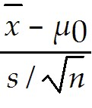

B) *z* = 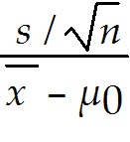

C) *z* = 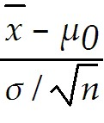

D) *t* = 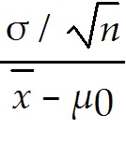

Answer: A

Diff: 1

Blooms: Remember

Topic: One-Sample Hypothesis Tests

LO1: Choose the proper test statistic for hypothesis tests involving means and proportions.

LO2: Compare and contrast the major types of hypothesis testing for one-sample tests

17) The average cost for the sample of 5 sales of a product is  = $230 and the sample standard deviation is *s* = $17.50. The hypothesized mean is *μ0* = $250. Compute the value of the test statistic.

A) -2.56

B) -4.00

C) -1.67

D) -3.87

Answer: A

Diff: 2

Blooms: Apply

AACSB: Analytic Skills

Topic: One-Sample Hypothesis Tests

LO1: Choose the proper test statistic for hypothesis tests involving means and proportions.

LO2: Compare and contrast the major types of hypothesis testing for one-sample tests

18) For a one-tailed test, the critical value:

A) divides the sampling distribution into three parts.

B) is the number of standard errors away from the sample mean.

C) **helps determine if the test statistic falls in the rejection region or not.**

D) fails to reject the null hypothesis if the test statistic exceeds the critical value.

Answer: C

Diff: 2

Blooms: Understand

Topic: One-Sample Hypothesis Tests

LO1: Explain how to draw a conclusion for one- and two-tailed hypothesis tests.

LO2: Compare and contrast the major types of hypothesis testing for one-sample tests

19) Which of the following is true about the rejection region?

A) The rejection region is chosen to determine the probability of a Type I error.

B) With a true null hypothesis, the test statistic falls into the rejection region.

C) If the test statistic is in the nonrejection region, the null hypothesis is rejected.

**D) The rejection region occurs in the tails of the sampling distribution of the test statistic.**

Answer: D

Diff: 2

Blooms: Understand

Topic: One-Sample Hypothesis Tests

LO1: Explain how to draw a conclusion for one- and two-tailed hypothesis tests.

LO2: Compare and contrast the major types of hypothesis testing for one-sample tests

20) Which of the following is true about one-tailed and two-tailed tests?

**A) For standard normal and *t*-distributions, which have a mean of zero, lower-tail critical values are negative and upper-tail critical values are positive.**

B) For an upper one-tailed test, if the test statistic is greater than the critical value, the decision would beto fail to reject the null hypothesis.

C) For a lower one-tailed test, if the test statistic is less than the critical value, the decision would be to fail to reject the null hypothesis.

D) For a two-tailed test, if the test statistic is either greater than the upper critical value or less than the lower critical value, the decision would be to fail to reject the null hypothesis.

Answer: A

Diff: 2

Blooms: Understand

Topic: One-Sample Hypothesis Tests

LO1: Explain how to draw a conclusion for one- and two-tailed hypothesis tests.

LO2: Compare and contrast the major types of hypothesis testing for one-sample tests

Use the data given below to answer the following question(s).

In a lower one-tailed hypothesis test, chosen level of significance = 0.10, sample size = 55, and t-test statistic = -1.76.

21) What is the observed level of significance?

A) 0.4605

B) 0.4191

C) 0.0379

D) 0.0420

Answer: D

Diff: 3

Blooms: Apply

AACSB: Analytic Skills

Topic: One-Sample Hypothesis Tests

LO1: Use p-values to draw conclusions about hypothesis tests.

LO2: Compare and contrast the major types of hypothesis testing for one-sample tests

22) Which of the following is the conclusion?

A) This is a high probability and the conclusion is difficult.

**B) The null hypothesis is rejected**.

C) There are many sampling errors.

D) The null hypothesis cannot be rejected.

Answer: B

Diff: 3

Blooms: Apply

AACSB: Analytic Skills

Topic: One-Sample Hypothesis Tests

LO1: Use p-values to draw conclusions about hypothesis tests.

LO2: Compare and contrast the major types of hypothesis testing for one-sample tests

23) Which of the following computes the test statistic for a one-sample test for proportions?

A) *z* = 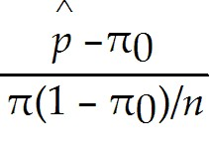

B) *z* = 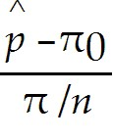

**C) *z =* 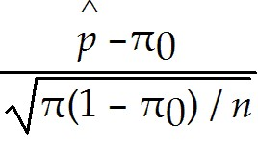**

D) *z =* 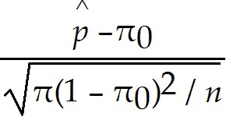

Answer: C

Diff: 1

Blooms: Remember

Topic: One-Sample Hypothesis Tests

LO1: Choose the proper test statistic for hypothesis tests involving means and proportions.

LO2: Compare and contrast the major types of hypothesis testing for one-sample tests

24) For a two-sample hypothesis which tests for differences in population parameters (1) and (2), a two-tailed test seeks evidence that population parameter:

A) seeks evidence that population parameter (2) is larger than parameter (1).

B) seeks evidence that population parameter (2) is the same as parameter (1).

C) seeks evidence that population parameter (2) is smaller than parameter (1).

D) seeks evidence that population parameters(1) and (2) do not belong to the same data.

Answer: B

Diff: 1

Blooms: Remember

Topic: Two-Sample Hypothesis Tests

LO1: State the proper forms of hypotheses for two-sample hypothesis tests.

LO2: Discuss the applications of the major types of two-sample tests

25) For a two-sample hypothesis test for differences in population parameters (1) and (2), which of the following is the correct form of an upper-tailed test?

A) *H*0: population parameter (1) - population parameter (2) ≥ 0 vs. *H*1: population parameter (1) - population parameter (2) < 0

B) *H*0: population parameter (1) - population parameter (2) > 0 vs. *H*1: population parameter (1) - population parameter (2) ≤ 0

C) *H*0: population parameter (1) - population parameter (2) < 0 vs. *H*1: population parameter (1) - population parameter (2) > 0

**D) *H*0: population parameter (1) - population parameter (2) ≤ 0 vs. *H*1: population parameter (1) - population parameter (2) > 0**

Answer: D

Diff: 1

Blooms: Remember

Topic: Two-Sample Hypothesis Tests

LO1: State the proper forms of hypotheses for two-sample hypothesis tests.

LO2: Discuss the applications of the major types of two-sample tests

26) In a two-sample test for differences in means, the hypotheses are of the form:

A) 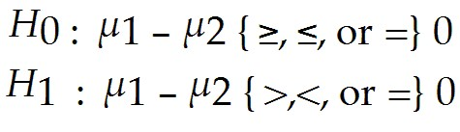

**B)** 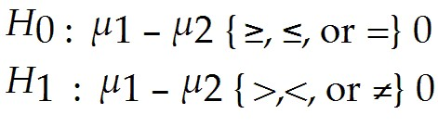

C) 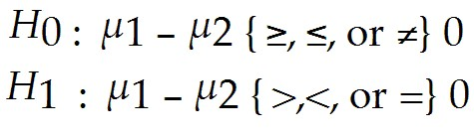

D) 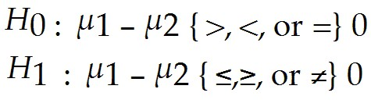

Answer: B

Diff: 1

Blooms: Remember

Topic: Two-Sample Hypothesis Tests

LO1: State the proper forms of hypotheses for two-sample hypothesis tests.

LO2: Discuss the applications of the major types of two-sample tests

27) For a lower-tail test, the *p*-value in the output from an Excel tool:

**A) is correct if the test-statistic is negative.**

B) is the difference from 1.0 if the test-statistic is negative.

C) is correct if the test-statistic is zero.

D) is correct if the test-statistic is positive.

Answer: A

Diff: 1

Blooms: Remember

Topic: Two-Sample Hypothesis Tests

LO1: Select and use Excel Analysis Toolpak procedures for two-sample hypothesis tests.

LO2: Discuss the applications of the major types of two-sample tests

28) Which of the following Excel tools is used for a two-sample test for equality of variances?

**A) Excel *F-*test Two-sample for variances**

B) Excel z*-*test: Two-sample for means

C) Excel *t-*test: Two-sample assuming unequal variances

D) Excel *t-*test: Two-sample assuming equal variances

Answer: A

Diff: 1

Blooms: Remember

Topic: Two-Sample Hypothesis Tests

LO1: Select and use Excel Analysis Toolpak procedures for two-sample hypothesis tests.

LO2: Discuss the applications of the major types of two-sample tests

29) While testing for equality of variances, which of the following formulae gives the *F-*test statistic?

A) 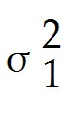 - 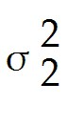

B) 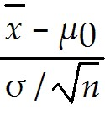

C) 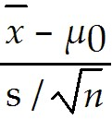

**D) $\frac{s_{1}^{2}}{s_{2}^{2}}$**

Answer: D

Diff: 1

Blooms: Remember

Topic: Two-Sample Hypothesis Tests

LO1: Explain the purpose of analysis of variance.

LO2: Discuss the applications of the major types of two-sample tests

30) In statistical terminology, the variable of interest is called a ________.

A) critical value

B) *p*-value

**C) factor**

D) test-statistic

Answer: C

Diff: 1

Blooms: Remember

Topic: Analysis of Variance

LO1: Explain the purpose of analysis of variance.

LO2: Discuss the applications of the major types of two-sample tests

31) Which of the following is true while applying the Excel ANOVA tool?

A) The specified input range of data must be separated.

B) The sample size for each factor level must be the same.

**C) The input range must be a rectangular region that contains all data.**

D) Level of significance need not be specified.

Answer: C

Diff: 1

Blooms: Understand

Topic: Analysis of Variance

LO1: Use the Excel ANOVA tool to conduct an analysis of variance test.

LO2: Discuss the applications of the major types of two-sample tests

32) In order to reject the null hypothesis, the *F*-test statistic must be greater than the ________.

A) *p*-value

B) variance

C) *df*

**D) *F crit***

Answer: D

Diff: 1

Blooms: Remember

Topic: Analysis of Variance

LO1: Use the Excel ANOVA tool to conduct an analysis of variance test.

LO2: Discuss the applications of the major types of two-sample tests

33) Which of the following tests is used to determine if two categorical variables are independent?

**A) Chi-square test**

B) *t*-test

C) *z*-test

D) ANOVA

Answer: A

Diff: 1

Blooms: Remember

Topic: Chi-Square Test for Independence

LO1: Conduct and interpret the results of a chi-square test for independence.

LO2: Discuss the applications of the major types of two-sample tests

34) Which of the following is true about chi-square distribution?

A) It is a special distribution and is denoted by (*C2*).

**B) It is characterized by degrees of freedom.**

C) It is computed using the Excel function CHISQ.INV.TEST.

D) It has a left-tail area equal to the expected value of the sample.

Answer: B

Diff: 1

Blooms: Understand

Topic: Chi-Square Test for Independence

LO1: Conduct and interpret the results of a chi-square test for independence.

LO2: Discuss the applications of the major types of two-sample tests

35) Which of the following 2010 Excel functions computes the *p*-value for the chi-square test?

A) CHISQ.INV.RT

B) CHIDIST

C) CHI.SQ

**D) CHISQ.TEST**

Answer: D

Diff: 1

Blooms: Remember

Topic: Chi-Square Test for Independence

LO1: Conduct and interpret the results of a chi-square test for independence.

LO2: Discuss the applications of the major types of two-sample tests

Use the data given below to answer the following question(s).

The following extract from a manufacturer's database shows a sample of 10 suppliers, their transportation charges, and the estimated and actual total costs of supplying materials. (Note: Assume a significance level of 0.05 wherever necessary.)

|  |  |  |  |
| --- | --- | --- | --- |
| **Supplier** | **Transportation**  **Charges** | **Estimated Total Cost** | **Actual Total Cost** |
| Peter | 340 | 4,500 | 4,680 |
| John | 560 | 4,500 | 4,790 |
| Martin | 480 | 4,500 | 5,110 |
| Philip | 290 | 4,500 | 4,780 |
| Mark | 370 | 4,500 | 4,810 |
| Thomas | 520 | 4,500 | 4,770 |
| Jaison | 350 | 4,500 | 5,250 |
| David | 430 | 4,500 | 4,930 |
| Carter | 510 | 4,500 | 5,010 |
| Leonard | 270 | 4,500 | 4,810 |

36) Conduct the appropriate type of one-sample test-statistic to determine whether the average transportation charge is less than $430.

Answer: The hypotheses take the form: *H*0: population parameter ≥ constant vs. *H*1: population parameter < constant

*H*0: population mean transportation charges ≥ $430 vs. *H*1: population mean transportation charges < $430

Average transportation charges for a sample of 10 suppliers () = $412

Sample standard deviation (*s*) = $102.18

Hypothesized mean (*μ*0) = $430

*t* = ( - *μ*0) / (*s* /✓*n*) = (412 - 430) / (102.18 /✓ 10) = (-18) / (32.31) = -0.56

The sample mean is 0.56 standard errors below the hypothesized value of 430. Since -0.56 > than Critical *t* -2.1318, there is insufficient evidence to conclude that the average transportation charges is below $430.

Diff: 3

Blooms: Apply

AACSB: Analytic Skills

Topic: One-Sample Hypothesis Tests

LO1: Choose the proper test statistic for hypothesis tests involving means and proportions.

LO2: Compare and contrast the major types of hypothesis testing for one-sample tests

37) Conduct the appropriate type of one-sample test-statistic to determine whether the average transportation charge is less than $430. Apply a decision rule using the observed level of significance and draw a conclusion.

Answer: If the true mean is 430, then the *p*-value is the probability of obtaining a test statistic of - 0.56 or less.

Using the Excel function TDIST(-0.56,9,TRUE), *p*-value = 0.2946.

Decision rule: Whenever *p*-value < chosen level of significance *α*, reject the null hypothesis and otherwise fail to reject it.

Because *p-*value is not less than *α* = 0.05, the null hypothesis cannot be rejected. There is about a 30% chance that the test statistic would be -0.56 or smaller if the null hypothesis was true. This is a fairly high probability, so it would be difficult to conclude that the true mean is less than 430. The fact that the sample mean is less than the hypothesized value can be attributed to sampling error alone.

Diff: 3

Blooms: Apply

AACSB: Analytic Skills

Topic: One-Sample Hypothesis Tests

LO1: Use p-values to draw conclusions about hypothesis tests.

LO2: Compare and contrast the major types of hypothesis testing for one-sample tests

38) On studying the database, the manufacturer found out that the average difference between the estimated and actual total costs was $394. Based on the sample data, can the manufacturer conclude that the average difference between the estimated and actual total costs is different from zero?

Answer: If *μD* denotes the population mean difference between the estimated and actual total costs, then the null and the alternative hypotheses are of the form,

*H*0: *μD* = 0 vs. *H*1: *μD* ≠ 0.

*t*-Test: Paired Two Sample for Means

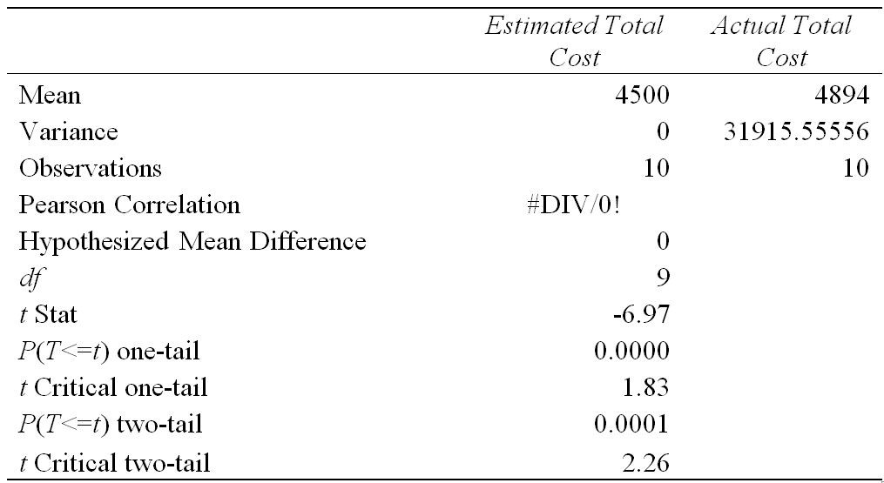

The above output from the Excel tool shows the critical values are ± 2.26. Since *t* Stat -6.97 is much smaller than the lower critical value -2.26, the null hypothesis is rejected. It can be concluded that the mean of the differences between the estimated and the actual total costs is statistically significant. The *p*-value 0.0001 too is essentially zero verifying this conclusion.

Diff: 3

Blooms: Apply

AACSB: Analytic Skills

Topic: Two-Sample Hypothesis Tests

LO1: State the proper forms of hypotheses for two-sample hypothesis tests. Select and use Excel Analysis Toolpak procedures for two-sample hypothesis tests.

LO2: Discuss the applications of the major types of two-sample tests

39) During a study, individuals were asked to rate a product on a scale of 1-5. From the following data, help the researcher determine whether any significant differences exist in opinions among individuals from different regions. (Note: Assume a significance level of 0.05 wherever necessary.)

|  |  |  |
| --- | --- | --- |
| **Quintasia** | **Paraland** | **Bayundera** |
| 3 | 1 | 5 |
| 4 | 4 | 1 |
| 2 | 2 | 3 |
| 5 | 2 | 2 |
| 1 | 3 | 2 |
| 5 | 5 | 5 |
| 3 | 5 | 1 |
|  | 1 | 4 |
|  | 4 |  |
|  | 2 |  |

Answer: The null hypothesis for ANOVA is that the population means of all groups are equal; the alternative hypothesis is that at least one mean differs from the rest:

*H*0: *μ*1 = *μ*2 = *μ*3 vs. *H*1:at least the mean from one region is different from others

Anova: Single Factor

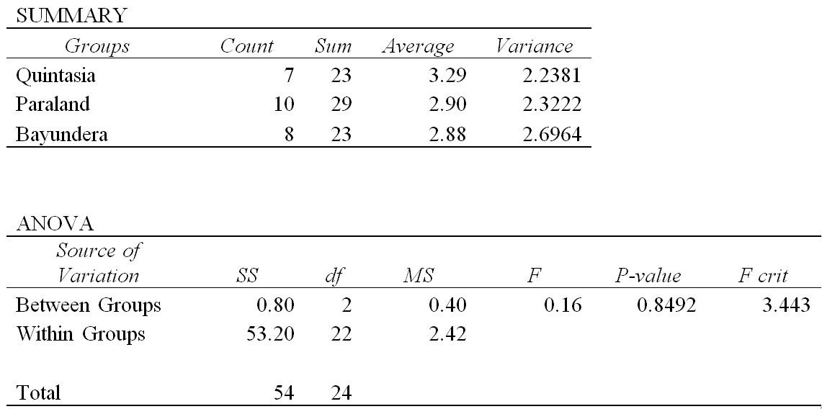

From the above results of the ANOVA test, *F* = 0.16 and *F crit* = 3.443. Clearly, *F*<*F crit*, which means that the null hypothesis cannot be rejected. It can be concluded that we do not have enough information to state that there are no significant differences in the opinions among the individuals from different regions. The *p*-value 0.8492 being greater than the chosen level of significance verifies the conclusion.

Diff: 3

Blooms: Apply

AACSB: Analytic Skills

Topic: Analysis of Variance

LO1: Use the Excel ANOVA tool to conduct an analysis of variance test.

LO2: Discuss the applications of the major types of two-sample tests

40) Using the following data, test for the independence of the variables. (Note: Assume a significance level of 0.05 wherever necessary.)

|  |  |  |
| --- | --- | --- |
| **Respondent** | **Gender** | **Breakfast Preference** |
| 1 | Female | Fruits |
| 2 | Male | Cereal |
| 3 | Male | Milk |
| 4 | Female | Fruits |
| 5 | Female | Milk |
| 6 | Male | Cereal |
| 7 | Male | Milk |
| 8 | Male | Milk |
| 9 | Female | Fruits |
| 10 | Male | Fruits |
| 11 | Male | Cereal |
| 12 | Female | Cereal |
| 13 | Female | Milk |
| 14 | Male | Fruits |
| 15 | Female | Fruits |

Answer: The chi-square test for independence tests the following hypotheses:

*H*0: the two categorical variables are independent

*H*1: the two categorical variables are dependent

Cross-tabulation table:

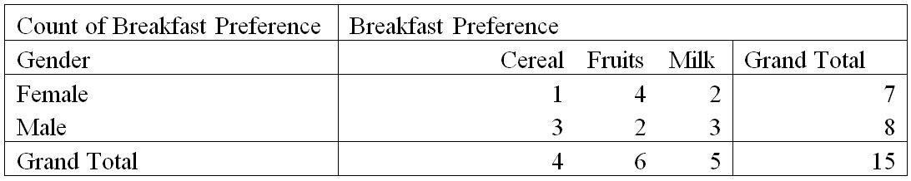

|  |  |  |  |  |
| --- | --- | --- | --- | --- |
| **Expected Frequency** | **Cereal** | **Fruits** | **Milk** | **Grand Total** |
| **Female** | 1.87 | 2.80 | 2.33 | 7.00 |
| **Male** | 2.13 | 3.20 | 2.67 | 8.00 |
| **Grand Total** | 4.00 | 6.00 | 5.00 | 15.00 |

The chi-square statistic is computed as *X2 =* 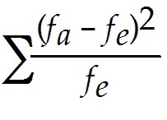, where *fo* is the observed frequency, and *fe* is the expected frequency.

|  |  |  |  |  |
| --- | --- | --- | --- | --- |
| **Chi Square Statistic** | **Cereal** | **Fruits** | **Milk** | **Grand Total** |
| **Female** | 0.40 | 0.51 | 0.05 | 0.96 |
| **Male** | 0.36 | 0.45 | 0.04 | 0.85 |
| **Grand Total** | 0.76 | 0.96 | 0.09 | **1.81** |

From the above table of calculations, the value of the chi-square statistic is 1.81.

From the cross-tabulation table, the number of rows r = 2 and number of columns c = 3.

*Degrees of freedom = (r-1)(c-1) = (2-1)(3-1) = 2*. *Chi-square critical = 5.991*.

*p*-value *= 0.4049*

The chi-square test returned a *p-*value greater than the chosen level of significance. Therefore, the null hypothesis cannot be rejected. We cannot state that thecategorical variables are dependent.

Diff: 3

Blooms: Apply

AACSB: Analytic Skills

Topic: Chi-Square Test for Independence

LO1: Conduct and interpret the results of a chi-square test for independence.

LO2: Discuss the applications of the major types of two-sample tests

**41) In conducting a hypothesis test, what is usually to be proven statistically is identified as the null hypothesis.**

**Answer: FALSE**

Diff: 1

Blooms: Remember

Topic: One-Sample Hypothesis Tests

LO1: Explain the difference between the null and alternative hypotheses.

LO2: Compare and contrast the major types of hypothesis testing for one-sample tests

**42) If the alternative hypothesis includes the symbol <, the rejection region is in the upper tail.**

**Answer: FALSE**

Diff: 1

Blooms: Remember

Topic: One-Sample Hypothesis Tests

LO1: Explain how to draw a conclusion for one- and two-tailed hypothesis tests.

LO2: Compare and contrast the major types of hypothesis testing for one-sample tests

**43) For a two-sample test for means with the population variance being known, the Excel procedure used is the Excel *z*-test.**

**Answer: TRUE**

Diff: 1

Blooms: Remember

Topic: Two-Sample Hypothesis Tests

LO1: Select and use Excel Analysis Toolpak procedures for two-sample hypothesis tests.

LO2: Discuss the applications of the major types of two-sample tests

**44) In a two-sample test for means with the population variance being known, the *z*-test uses a test statistic that is based on the standard normal distribution.**

**Answer: TRUE**

Diff: 1

Blooms: Remember

Topic: Two-Sample Hypothesis Tests

LO1: Explain how to draw a conclusion for one- and two-tailed hypothesis tests.

LO2: Discuss the applications of the major types of two-sample tests

**45) The first step in a chi-square test is to compute the observed frequency between each cell of the cross-tabulation if the two variables are independent.**

**Answer: FALSE**

Diff: 1

Blooms: Remember

Topic: Chi-Square Test for Independence

LO1: Conduct and interpret the results of a chi-square test for independence.

LO2: Discuss the applications of the major types of two-sample tests

46) What are the four different outcomes of hypothesis testing?

Answer: Hypothesis testing can result in one of four different outcomes:

• The null hypothesis is actually true, and the hypothesis test correctly fails to reject it.

• The null hypothesis is actually false, and the hypothesis test correctly rejects it.

• The null hypothesis is actually true, but the hypothesis test incorrectly rejects it (called Type I error).

• The null hypothesis is actually false, but the hypothesis test incorrectly fails to reject it (called Type II error).

Diff: 2

Blooms: Remember

Topic: One-Sample Hypothesis Tests

LO1: List the four possible outcome results from a hypothesis test.

LO2: Compare and contrast the major types of hypothesis testing for one-sample tests

**47) How do test statistics for two-sample tests vary depending on whether the population standard deviations are known, and if not, whether they are assumed to be equal?**

Answer: Selection of the proper test statistic for a two-sample test for means depends on whether the population standard deviations are known, and if not, whether they are assumed to be equal.

• *Population variance is known.* In Excel 2010, choose *z-Test: Two-Sample for Means* from the *Data Analysis* menu. This test uses a test statistic that is based on the standard normal distribution.

• *Population variance is unknown and assumed unequal.* From the *Data Analysis* menu, choose *t*-*test: Two-Sample Assuming Unequal Variances*. The test statistic for this case has a *t*-distribution.

• *Population variance unknown but assumed equal.* In Excel, choose *t*-*test: Two-Sample Assuming Equal Variances.* The test statistic also has a *t-*distribution, but it is different from the unequal variance case.

Diff: 2

Blooms: Understand

Topic: Two-Sample Hypothesis Tests

LO1: Select and use Excel Analysis Toolpak procedures for two-sample hypothesis tests.

LO2: Discuss the applications of the major types of two-sample tests

48) For a two-sample test, explain the procedure used when it is difficult to justify the assumption that the variances of each population are equal.

Answer: Only rarely are the population variances known; also, it is often difficult to justify the assumption that the variances of each population are equal. Therefore, in most practical situations, the *t*-*test: Two-Sample Assuming Unequal Variances* is used. This procedure also works well with small sample sizes if the populations are approximately normal. It is recommended that the size of each sample be approximately the same and total 20 or more. If the populations are highly skewed, then larger sample sizes are recommended.

Diff: 2

Blooms: Understand

Topic: Two-Sample Hypothesis Tests

LO1: Select and use Excel Analysis Toolpak procedures for two-sample hypothesis tests.

LO2: Discuss the applications of the major types of two-sample tests

**49) Explain the assumptions underlying ANOVA along with their violations.**

**Answer: ANOVA requires assumptions that the *m* groups or factor levels being studied represent populations whose outcome measures:**

• are randomly and independently obtained,

• are normally distributed, and

• have equal variances.

If these assumptions are violated, then the level of significance and the power of the test can be affected. If sample sizes are equal, violation of the third assumption does not have serious effects on the statistical conclusions; however, with unequal sample sizes, it can. A *nonparametric* test may be used when the assumptions underlying ANOVA are violated.

Diff: 2

Blooms: Understand

Topic: Analysis of Variance

LO1: List the assumptions of ANOVA.

LO2: Discuss the applications of the major types of two-sample tests

50) Why is testing for independence important for businesses?

Answer: A common problem in business is to determine whether two categorical variables are independent. With sample data, sampling error can make it difficult to properly assess independence of categorical variables. The joint probabilities would never be expected to be exactly the same as the product of the marginal probabilities because of sampling error even if the two variables are statistically independent. Testing for independence is important in marketing applications.

Diff: 2

Blooms: Understand

Topic: Chi-Square Test for Independence

LO1: Conduct and interpret the results of a chi-square test for independence.

LO2: Discuss the applications of the major types of two-sample tests